CURRICULUM VITAE (CV)

Amany Abdel- Rahman Osman Mohammed Dief 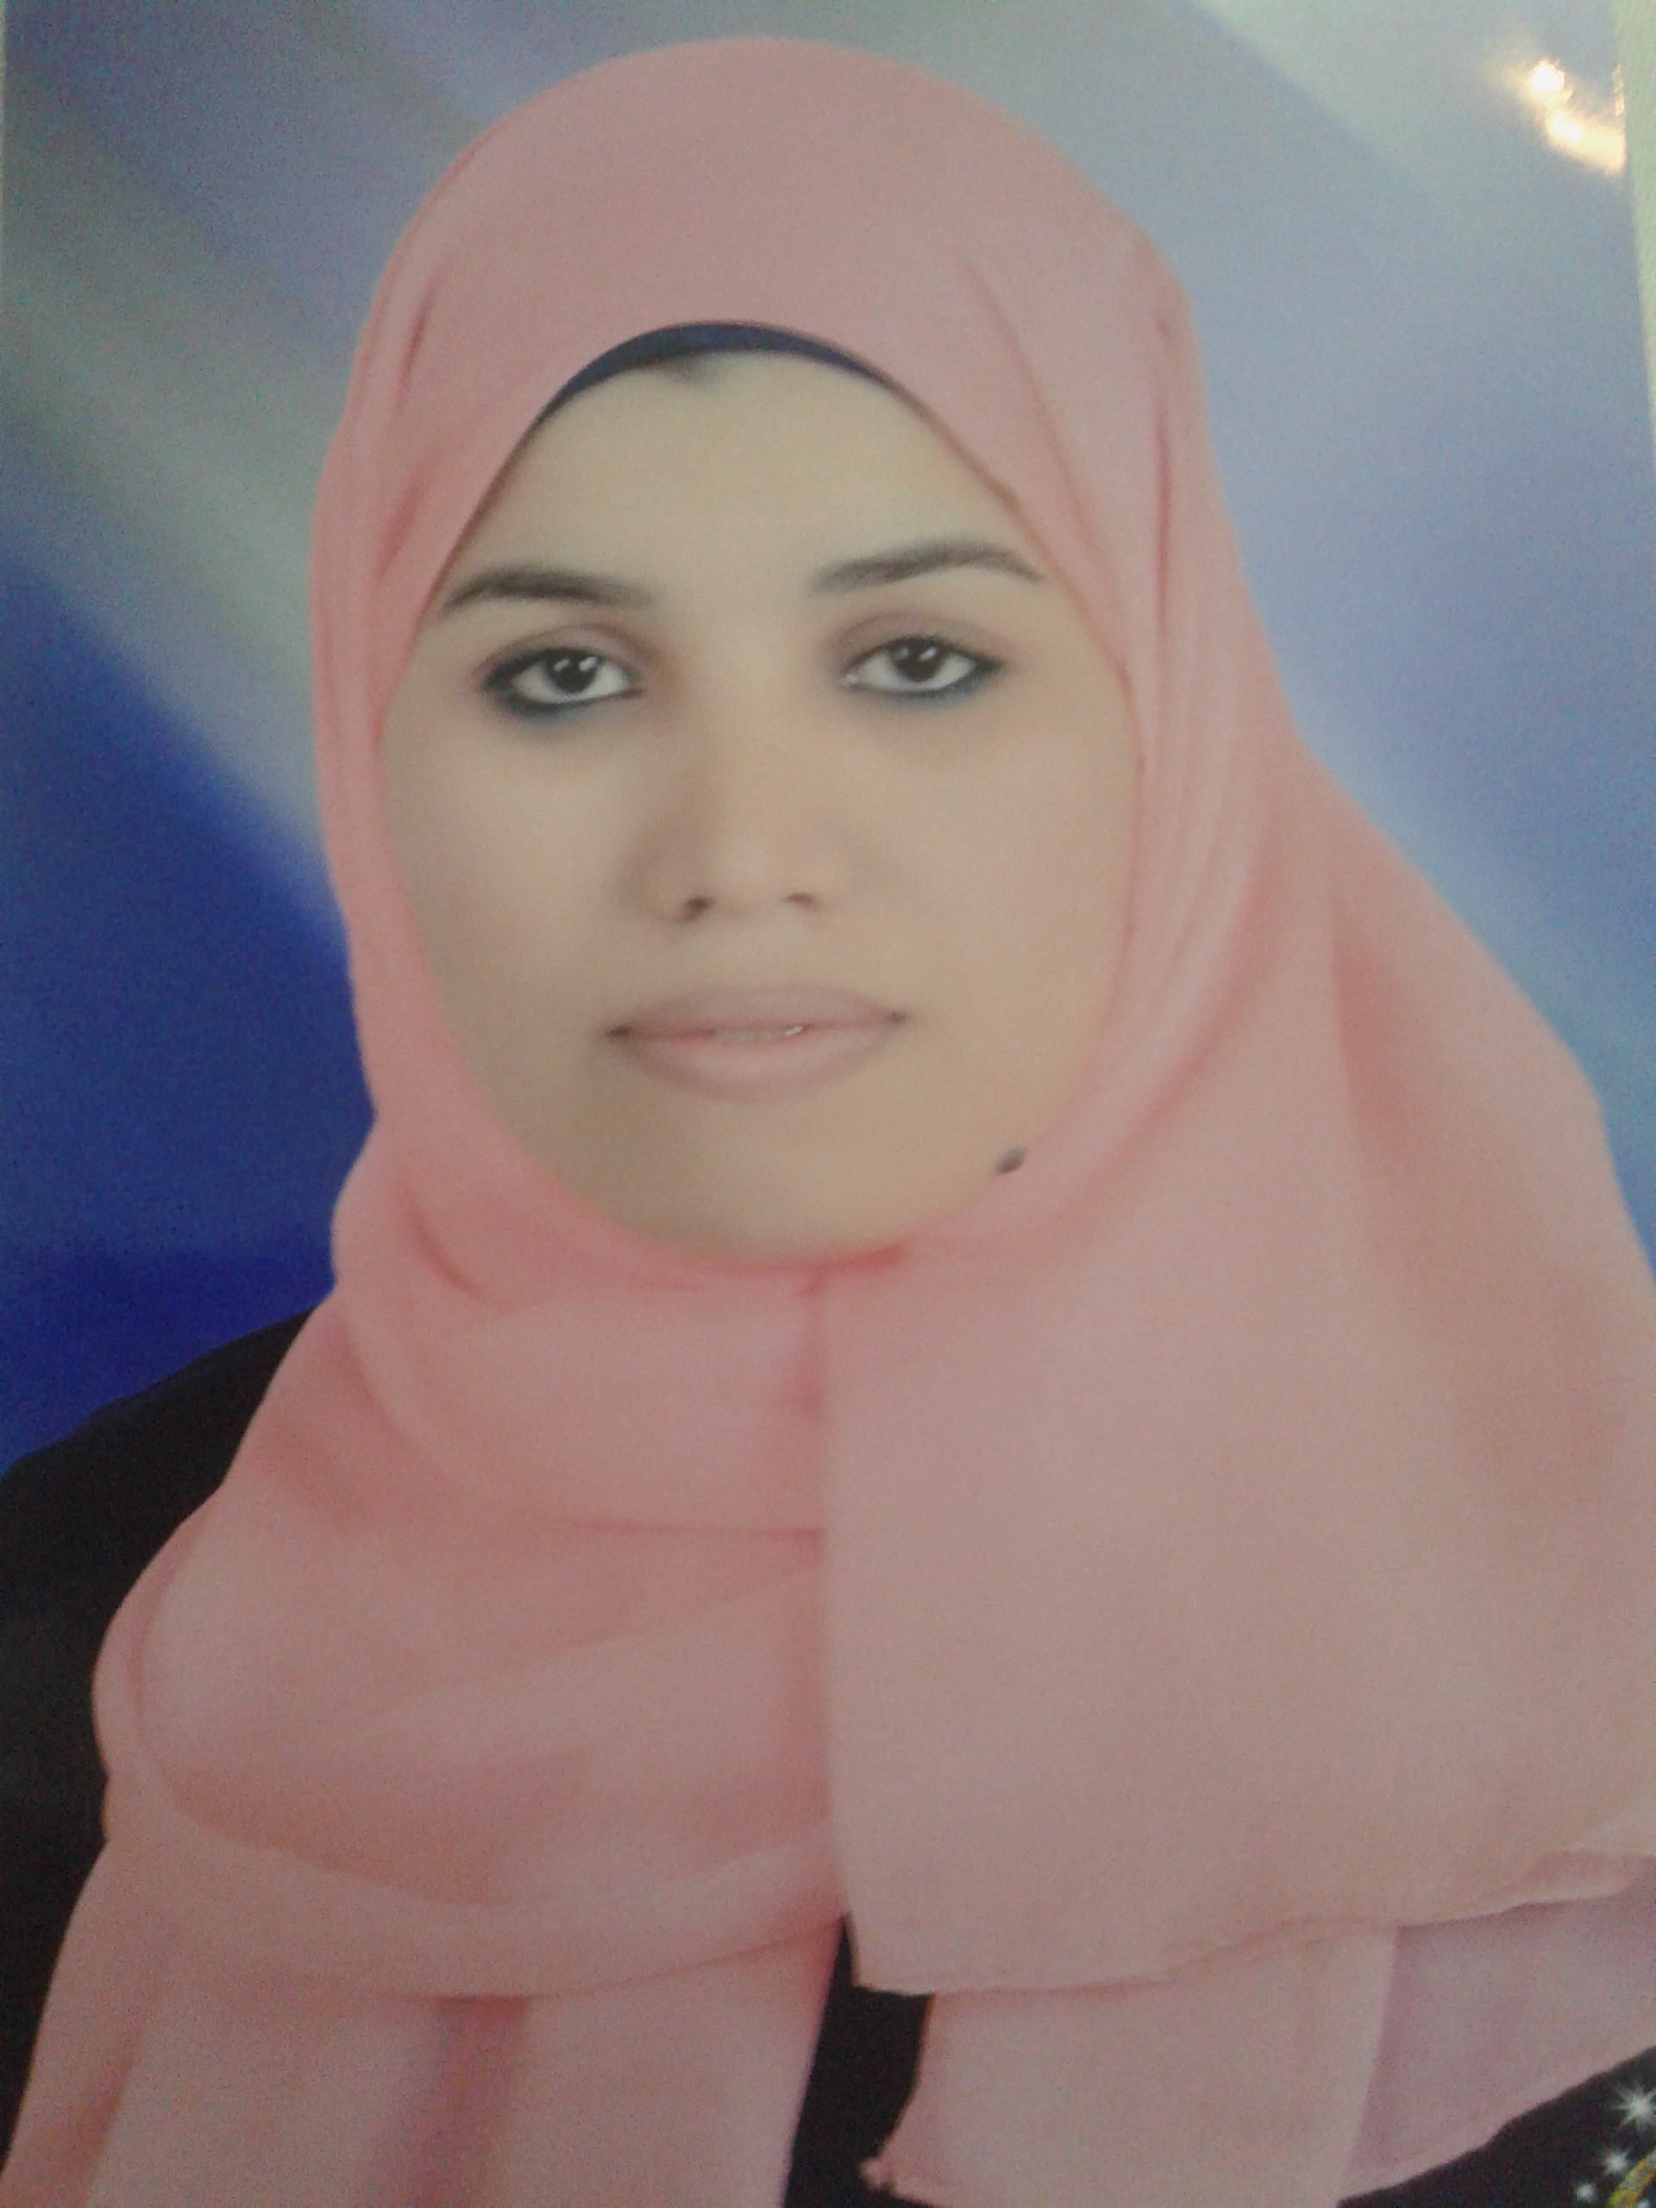
Assistant Lecturer at Chemistry Department, Faculty of Science, Assiut University.

Objective:-

I want to get a PhD degree in biochemistry and become a scientist with a big affair in a specialized field of biochemistry and always add what is new in this science.

Personal data:-

Date& Place of Birth: January, 7, 1989, El-Zawia, Assiut, Egypt

Gender: Female

Telephone: 002-0102-0478052(Mobile)

Marital Status: Single
Permanent Address: Chemistry Department, Faculty of Science,
Assiut University, Assiut, Egypt.

E-mail: Amanyabdo92@yahoo.com
Amanyabdelrahman6@gmail.com

Academic e- mail: amanyabdelrahman@aun.edu.eg

Education:-

- B.Sc. in Chemistry from Assiut University (June 2009)

Grade: Excellent with honors (88.35%).
- M.Sc.in (Biochemistry) from Assiut University, January2015 under the title of:
”Biochemical Studies on the Activity of Glutathione – S –Transeferase in some Organs of Aflatoxicosed Animals”

Conferences and Training Courses:-

- Having ICDL Certificate.
- Training in Assiut Oil Refining Company (ASORC).
- Training in Technical Center for Scientific equipment and training in "Means of safety and security in the labs” 13-14th October 2010.
- Training in Technical Center for Scientific equipment and
training in "Analysis using Analytical Chromatographic
techniques, GC and HPLC” 4-5th January 2011.
- The 3rd Conference for Young Researchers, Basic Science & Technology, Assiut, 19-20th April 2011.
- The 4th International Conference for Young Researchers, 29- 30 April 2014, Assiut, Egypt.

